

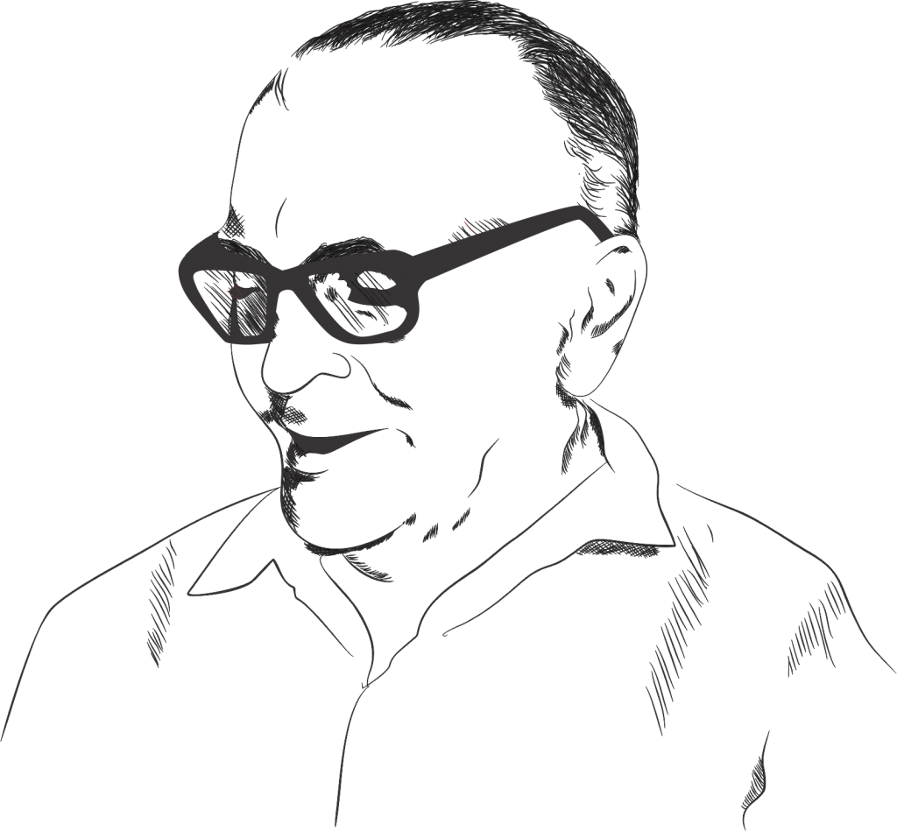



## **Thanthai Roever college of Engineering & Technology**

Name : Aravindh

Dept : Mech Anbazhagan

Sec : A Principal